**SQL Lab Practice-2**

***Create the following Sales table***

**1. Retrieve all columns from the Sales table.**

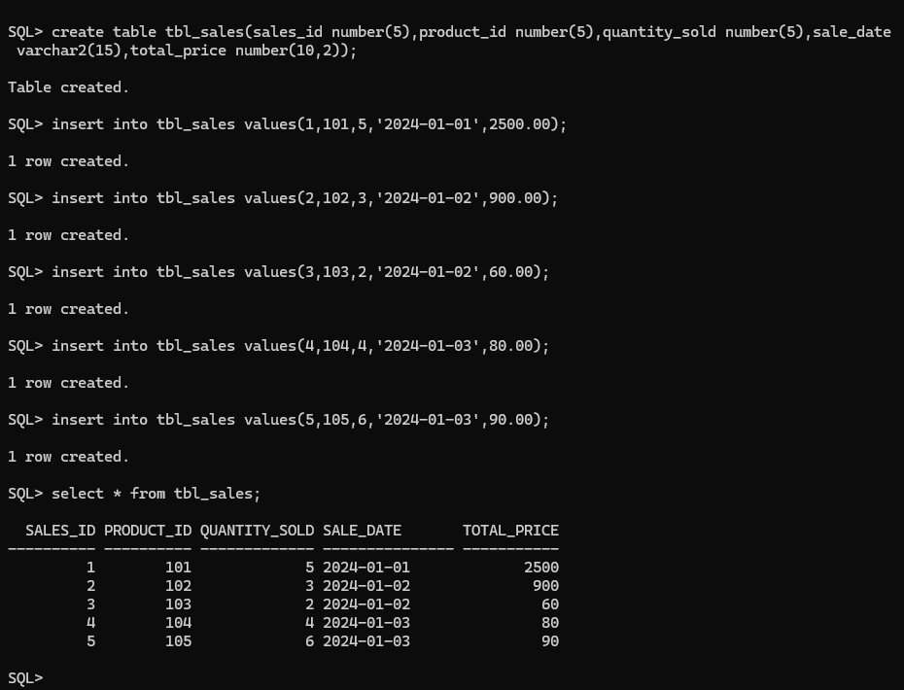

**2. Retrieve sale_id and quantity_sold from sales table.**

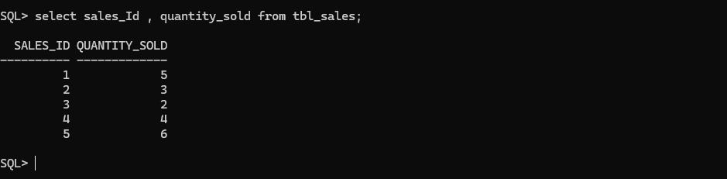

### 3. Retrieve the sale_id and sale_date from the Sales table.

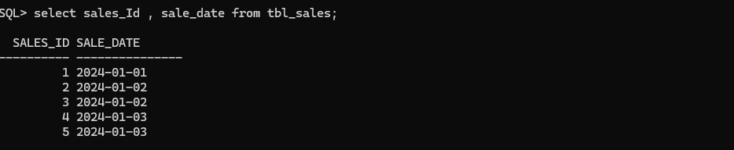

### 4. Filter the Sales table to show only sales with a total_price greater than $100.

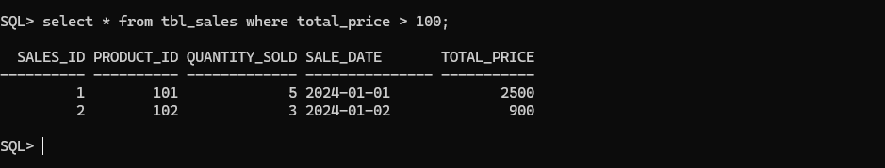

### 5. Retrieve the sale_id and total_price from the Sales table for sales made on January 3, 2024.

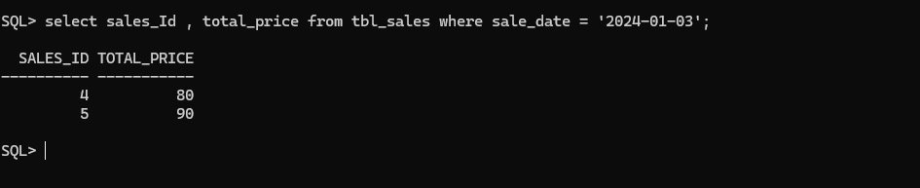

### 6. Retrieve the sale_id, product_id, and total_price from the Sales table for sales with a quantity_sold greater than 4.

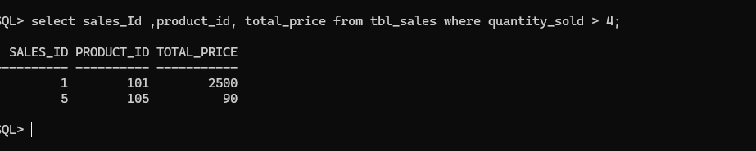

**7. Retrieve all columns from the Sales table those sale_id are 1, 3 & 5.**

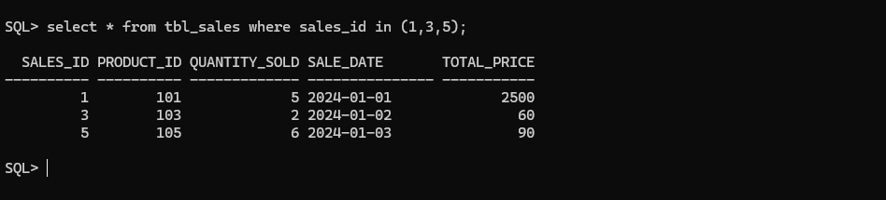

**8. Retrieve all columns from the Sales table those total_price between 90 and 1000.**

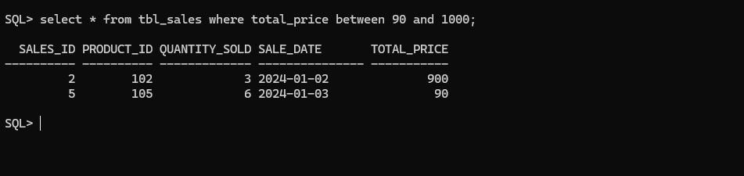

**9. Retrieve all columns from the Sales table those total_price not between 90 and 1000.**

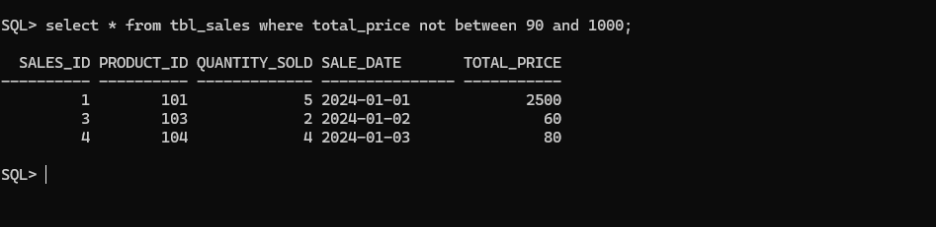

**10. Retrieve all columns from the Sales table those sale_id are not in 1, 3 & 5.**

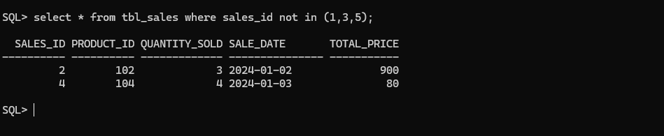

**11. Update total_price as 500 in the Sales table those sale_id are 1, 3 & 5.**

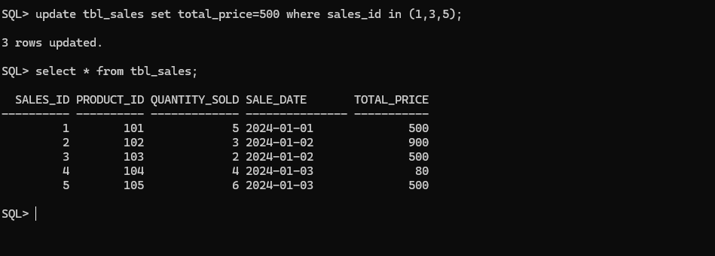

**12. delete from the Sales table those total_price not between 90 and 1000.**

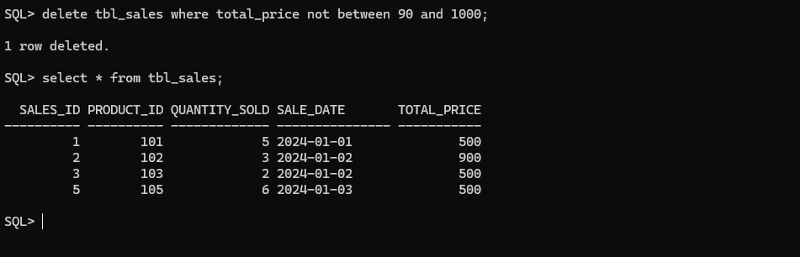

**13. Sort all the records using sale_id column in ascending order.**

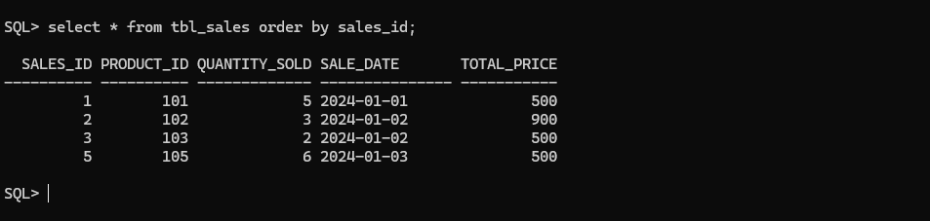

1. **Sort all the records using sale_id column in descending order.**

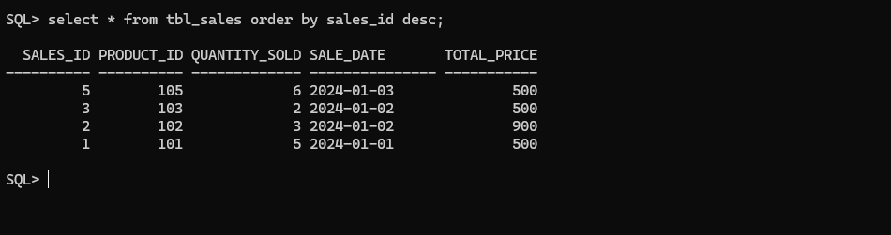

**15. Rename the sale_id column as sales_id;**

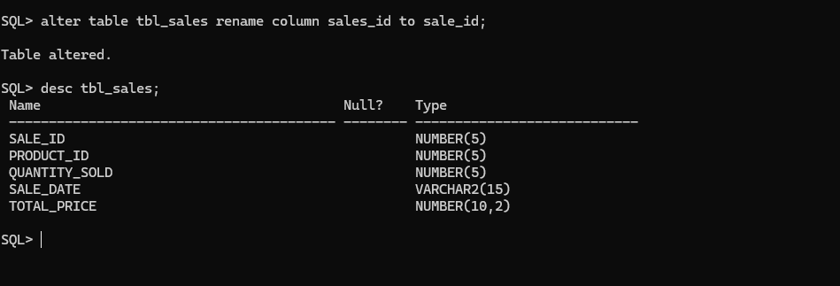

1. **Drop the column sales_id.**

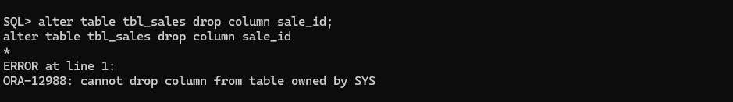

1. **Rename the table as tbl_sales.**

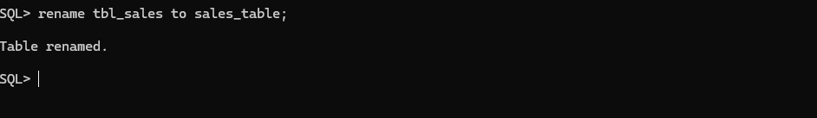

1. **Drop the table.**

